**­­­**



**DESIGN DOCUMENT**

**TechTonic**

**(Techtonic Software)**

|  |
| --- |
| Team |
| **Benjamin Chinwe** |
| **Daniel Fasanmi** |
| **Emmanuel Eke** |
| **Prasanna Tontalapur** |

Table of Contents

USECASE DIAGRAM .................................................................................. 2

SYSTEM ARCHITECTURE DIAGRAM................................................. 3

DATABASE ENTITY RELATIONSHIP DIAGRAM ......................................................... 4 UML DIAGRAM .............................................................................................................. 5 Complete UML .......................................................................................................... 5 Simplified UML .......................................................................................................... 6 SOFTWARE DESIGN SCREENS ..................................................................................... 7

**USECASE DIAGRAM**

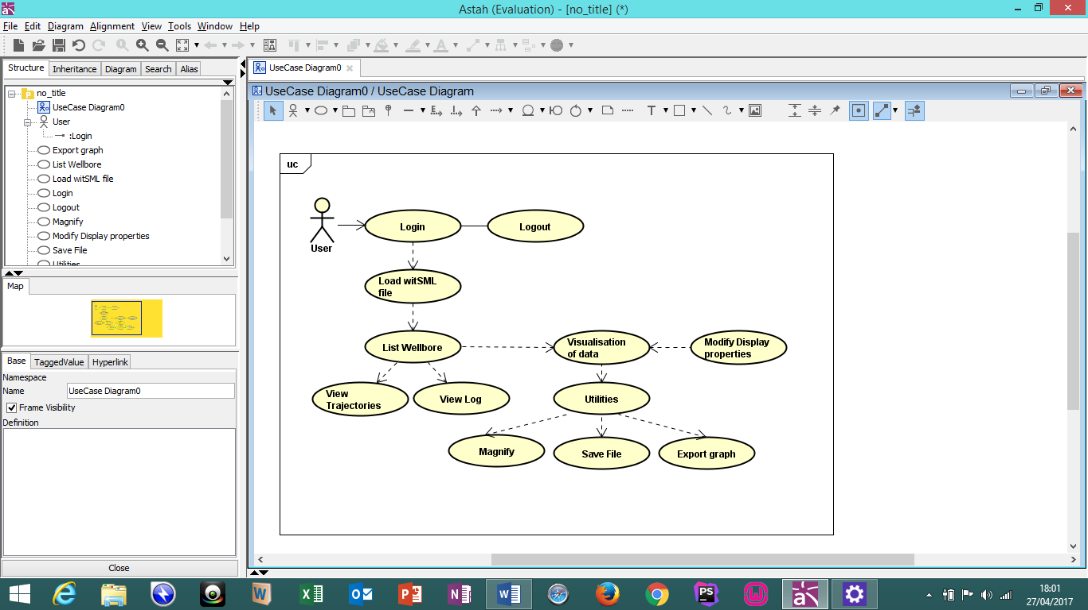

**SYSTEM ARCHITECTURE DIAGRAM**

User

User Interface

Logic / Presentation

Browser Interface

Chrome / Firefox

Database

Storage / System

Application (Logic/Components)

PHP

XML

Java

**DATABASE ENTITY RELATIONSHIP DIAGRAM**

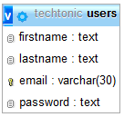

**UML DIAGRAM**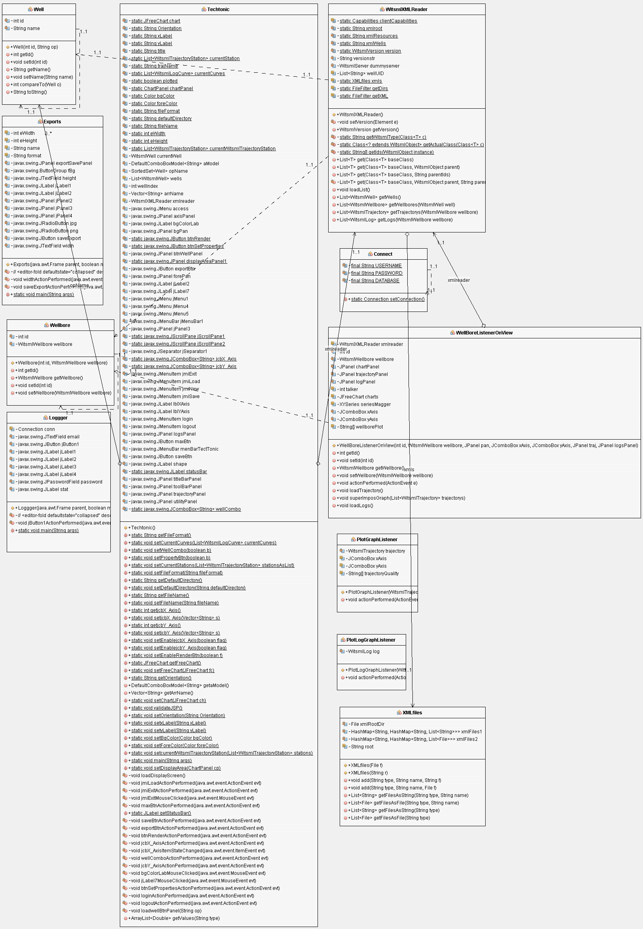

**SOFTWARE DESIGN SCREENS**

**Note: For the sake of the testing. The application has been hard coded to take david (case ignored) as the username and password.**

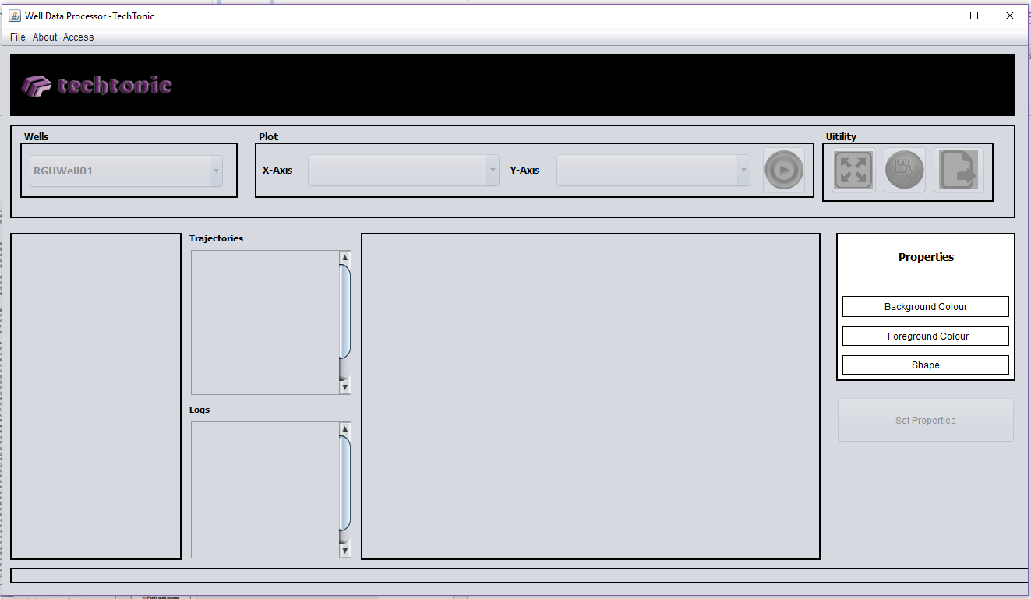

**Fig . 1. When the application is first launched**

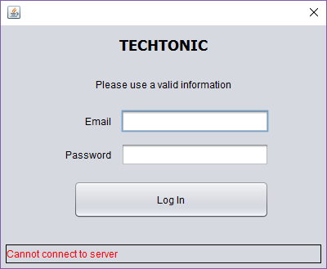

**Fig. 2 Login screen for intending user**

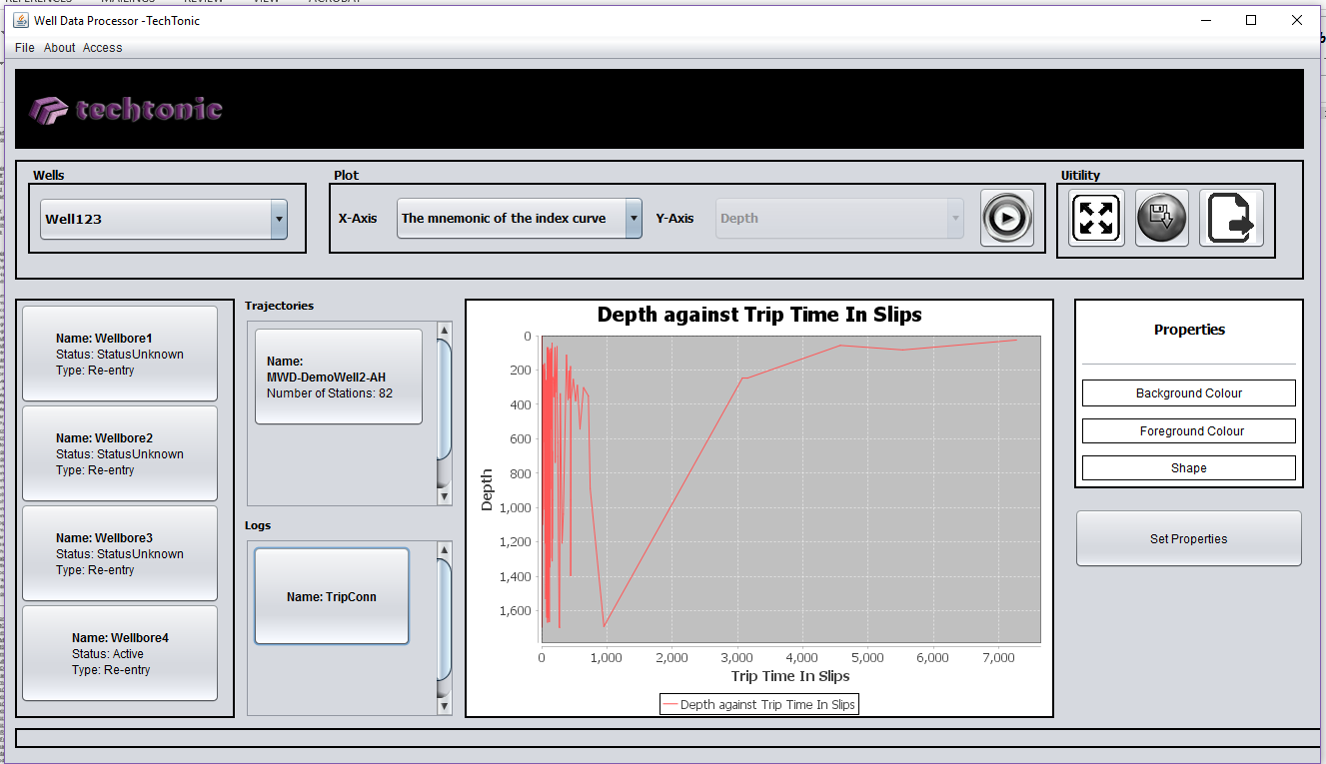

**Fig.3 The application displaying log data visualization**

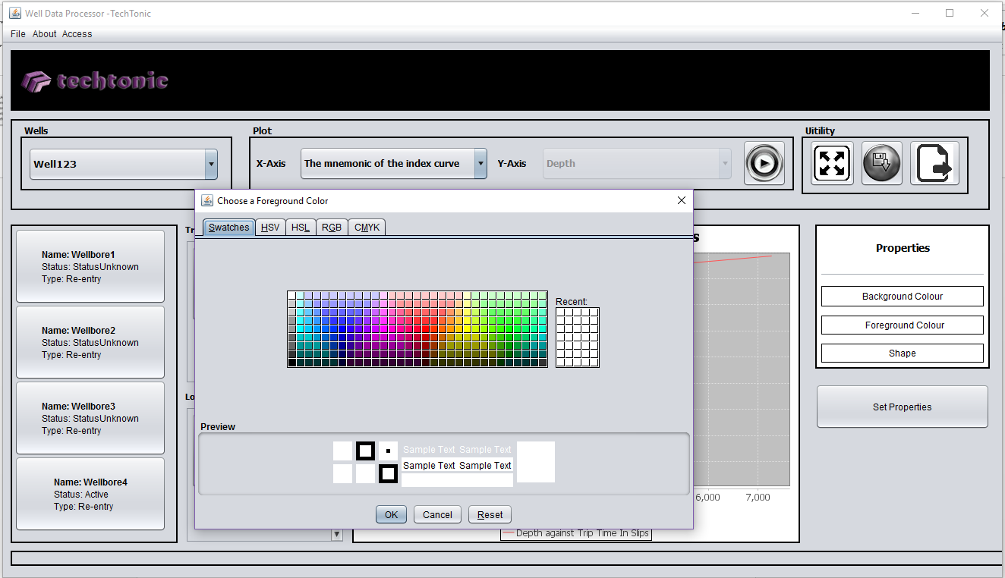

**Fig. 4 changing the colour of the graph**

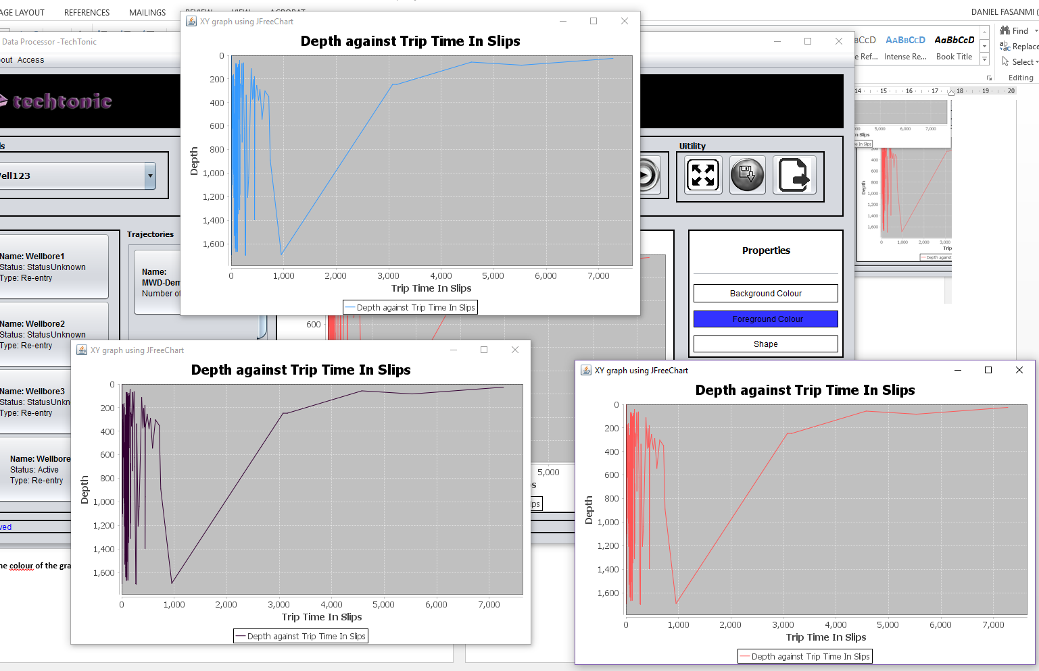

**Fig. 5 Displaying the same graph with different colour.**

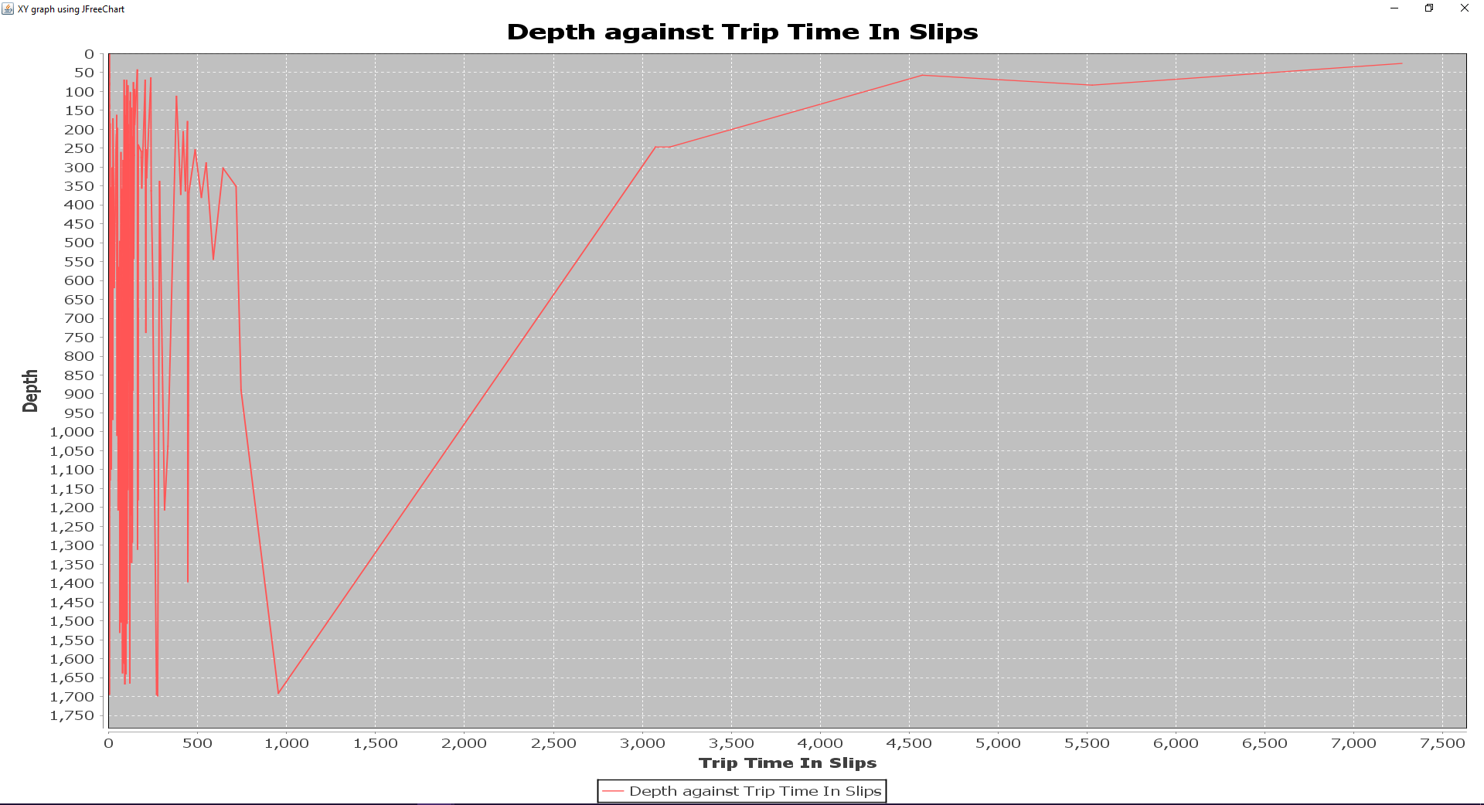

**Fig. 6 Using magnify button to visualize on a bigger frame, you can also zoom into the visualization by dragging the mouse on the area you want to zoom into.**

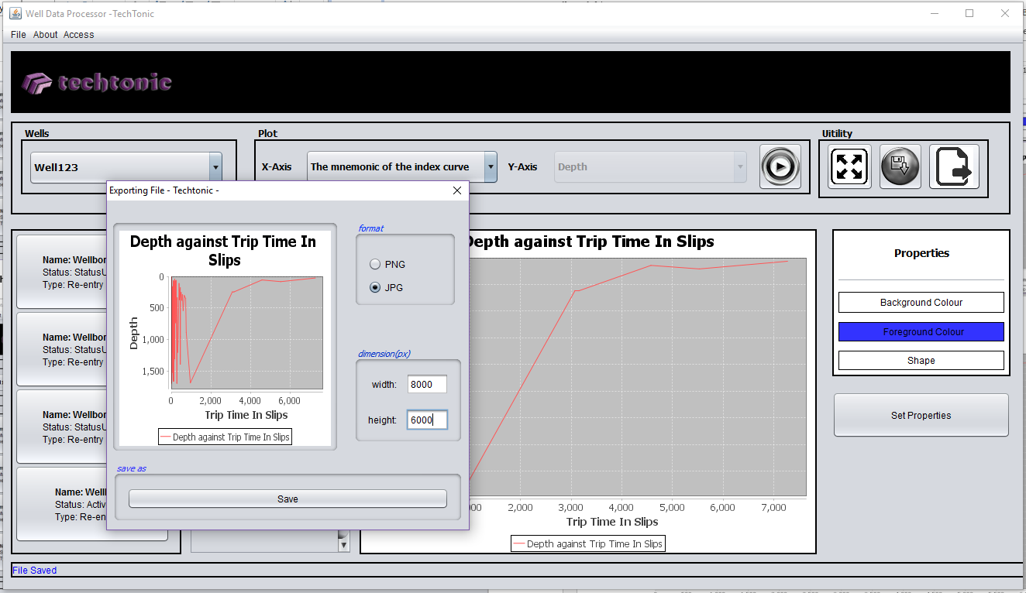

**Fig.7 The export button allows you to export the file in a desired file format (png, jpg) and change the size of the visualization as desired.**

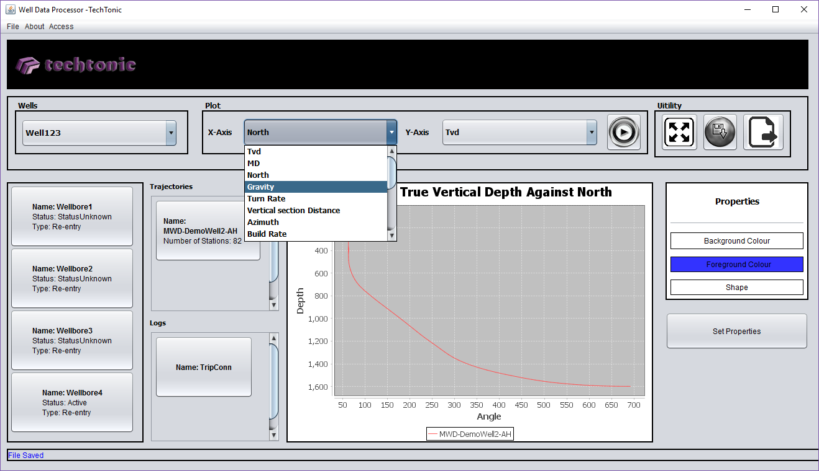

**Fig. 8 Manipulating the axis of the displayed to suite users preference.**

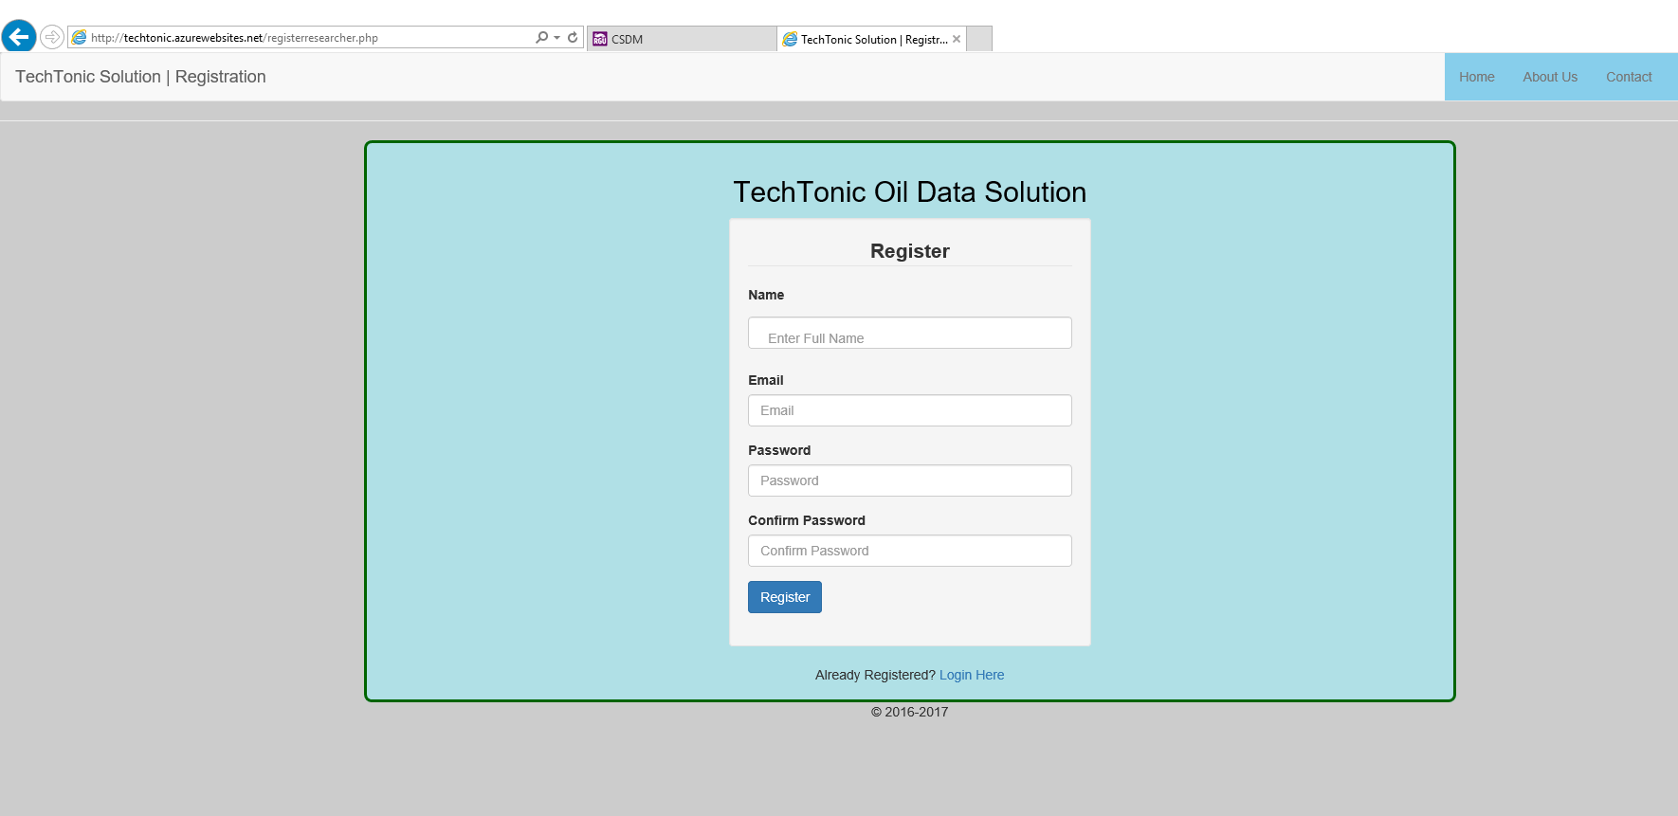

**Fig. 9 The registration page which is used by the HR to grant access to new employees. It is hosted on azure server (htttp://techtonic.azurewebsites.net)**